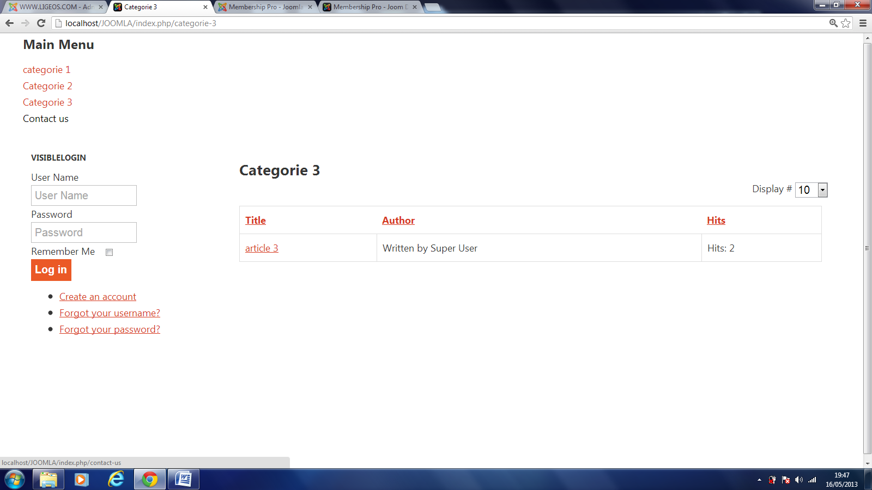

Click on create an account link

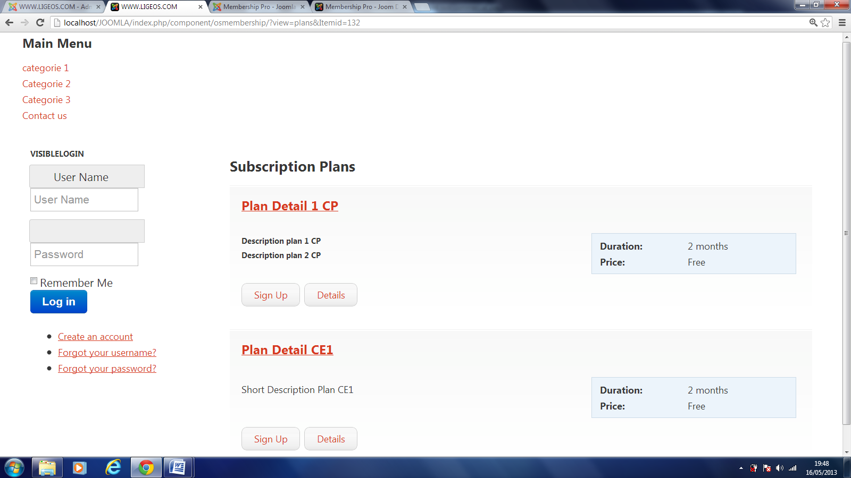

Result:
1. The display is not in line with the set up specified for my template. Duration and Price are in a blue box and that has not been specified in my template.
2. The display of the login box has changed. User Name is now in a blue box! (highlighted in red)

