Display problem after upgrade to eDocman (not solved since 1.5.5 !)
Personal note : sometimes, after update of eDocman, not all the (new) configuration is taken into account. In that case, simply open Configuration screen & click on save to “activate” it.
Problem description
eDocman 1.5.5 and newer now integrates bootstrap.
But this change came along with two display problems on the website :
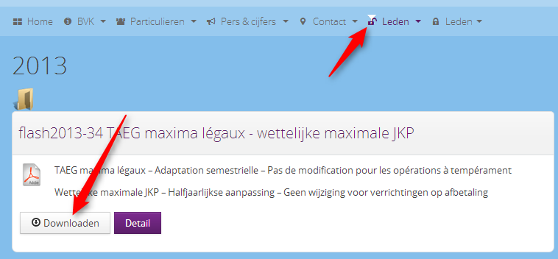
Problem #1 (conflict with some templates)
On the menu item giving access to eDocman comes an additional (unwanted) glyph_icon, looking like a down arrow, but in fact probably a cocktail glass.
NB : the template used in this example is JA Mero by Joomlart
Problem #2 (universal problem)
The Download button has been improved in eDocman 1.5.5 : a new icon illustrates each button.
But the Detail button
- has a different layout from all other buttons
- has no assigned icon
On the way to a solution
After having introduced sent ticket to JoomDonation, Tuan & his dev have provided following improvement : all buttons are now harmonized (in the color of the template, ie with class btn-primary). But in the process all the icons are lost. See screenshot hereafter :
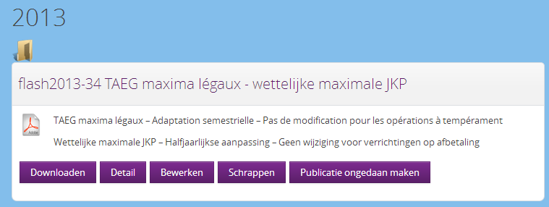
Based on that work, we want to go to one step further: still having all buttons harmonized, but with their corresponding icons, like this :
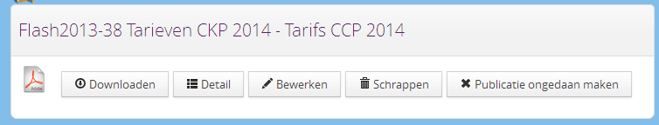
How to do it
Both problems require a hack.
While problem #1 would only arise in certain circumstances (like here because of a style conflict with template), problem #2 is general and should require a correction for the next version.
Correcting the broken menu of the website (problem #1)
Edit following file
/components/com_edocman/assets/css/style.css
And delete (or better: disable to keep track) following lines (around line 956 in version 1.6.0, line 984 in version 1.7.0)
.icon-white, .nav>.active>a>[class^="icon-"], .nav>.active>a>[class*=" icon-"], .dropdown-menu>li>a:hover>[class^="icon-"], .dropdown-menu>li>a:hover>[class*=" icon-"], .dropdown-menu>.active>a>[class^="icon-"], .dropdown-menu>.active>a>[class*=" icon-"] {
background-image: url("../images/glyphicons-halflings-white.png");
}
NB : in my case, don’t forget to clear jSGCache in order to have a refresh of style.css in the browser !
NB : by the way, JoomDonation had also deleted the following lines, but I have kept them as they allow to show the icons
[class^="edocman-icon-"],
[class*="edocman-icon-"] {
display: inline-block;
width: 14px;
height: 14px;
margin-top: 1px;
*margin-right: .3em;
line-height: 14px;
vertical-align: text-top;
background-image: url("../bootstrap/img/glyphicons-halflings.png");
background-position: 14px 14px;
background-repeat: no-repeat;
}
*/
/* White icons with optional class, or on hover/focus/active states of certain elements */
/* Woluweb - disabled by Joomdonation to solve display problem
.edocman-icon-white,
.nav-pills > .active > a > [class^="edocman-icon-"],
.nav-pills > .active > a > [class*=" edocman-icon-"],
.nav-list > .active > a > [class^="edocman-icon-"],
.nav-list > .active > a > [class*=" edocman-icon-"],
.navbar-inverse .nav > .active > a > [class^="edocman-icon-"],
.navbar-inverse .nav > .active > a > [class*=" edocman-icon-"],
.dropdown-menu > li > a:hover > [class^="edocman-icon-"],
.dropdown-menu > li > a:focus > [class^="edocman-icon-"],
.dropdown-menu > li > a:hover > [class*=" edocman-icon-"],
.dropdown-menu > li > a:focus > [class*=" edocman-icon-"],
.dropdown-menu > .active > a > [class^="edocman-icon-"],
.dropdown-menu > .active > a > [class*=" edocman-icon-"],
.dropdown-submenu:hover > a > [class^="edocman-icon-"],
.dropdown-submenu:focus > a > [class^="edocman-icon-"],
.dropdown-submenu:hover > a > [class*=" edocman-icon-"],
.dropdown-submenu:focus > a > [class*=" edocman-icon-"] {
background-image: url("../img/glyphicons-halflings-white.png");
}

By the way, changing
background-image: url("../bootstrap/img/glyphicons-halflings.png");
into
background-image: url("../bootstrap/img/glyphicons-halflings-white.png");
would allow to have the white icons… for example if using a darker background color for the buttons (see btn-primary hereafter)
Correcting the icon and the bad color of the Detail button (problem #2)
When inspecting the page (before the buttons are harmonized), one can see that
- All buttons have a class looking like “edocman-icon-xyz”… except button Detail
- All links of the buttons have a class “btn”, except button Detail which has also class “button-primary”
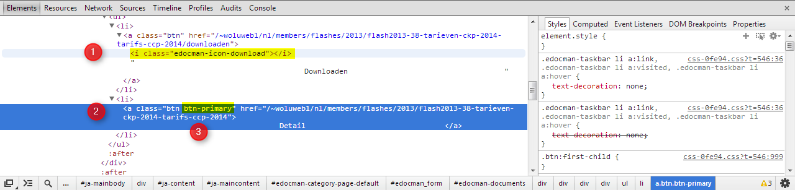
Edit following file
/components/com_edocman/view/common/documents_default.php
like this
Original 1.5.5 version (not correct) | Improved 1.5.5 version with two corrections for edocman_detail  - btn-primary has been removed  - class edocman-icon-th-list has been added
<?php  if ($canDownload && $config->hide_download_button !== '1')  {  ?>  <li>  <a class="btn" href="<?php echo $downloadUrl; ?>">  <i class="edocman-icon-download"></i>  <?php echo JText::_('EDOCMAN_DOWNLOAD'); ?>  </a>  </li>  <?php  }  if ($canDownload && $config->show_view_button && $item->canView)  {  $viewUrl = JRoute::_('index.php?option=com_edocman&task=document.viewdoc&id='.$item->id.'&Itemid='.$Itemid) ;  ?>  <li>  <a class="btn" href="<?php echo $viewUrl; ?>" target="_blank">  <i class="edocman-icon-eye-open"></i>  <?php echo JText::_('EDOCMAN_VIEW'); ?>  </a>  </li>  <?php  }  ?>  <li>  <a class="btn btn-primary" href="<?php echo $url; ?>" <?php echo $popup; ?>>  <?php echo JText::_('EDOCMAN_DETAILS'); ?>  </a>  </li> | <?php  if ($canDownload && $config->hide_download_button !== '1')  {  ?>  <li>  <a class="btn" href="<?php echo $downloadUrl; ?>">  <i class="edocman-icon-download"></i>  <?php echo JText::_('EDOCMAN_DOWNLOAD'); ?>  </a>  </li>  <?php  }  if ($canDownload && $config->show_view_button && $item->canView)  {  $viewUrl = JRoute::_('index.php?option=com_edocman&task=document.viewdoc&id='.$item->id.'&Itemid='.$Itemid) ;  ?>  <li>  <a class="btn" href="<?php echo $viewUrl; ?>" target="_blank">  <i class="edocman-icon-eye-open"></i>  <?php echo JText::_('EDOCMAN_VIEW'); ?>  </a>  </li>  <?php  }  ?>  <li>  <a class="btn" href="<?php echo $url; ?>" <?php echo $popup; ?>>  <i class="edocman-icon-th-list"></i>  <?php echo JText::_('EDOCMAN_DETAILS'); ?>  </a>  </li>
Original 1.5.7 version (not correct) – line 371 | Improved 1.5.7 version  NB : on supprime le btn-primary pour les boutons de la fenêtre modale sinon le bouton detail est le seul à être « btn-primary »
$popup = 'class="edocman-modal btn btn-primary" rel="{handler: \'iframe\', size: {x: 800, y: 500}}"';  <a href="<?php echo $url; ?>" <?php echo $popup; ?>>  <?php echo JText::_('EDOCMAN_DETAILS'); ?>  </a> | $popup = 'class="edocman-modal btn btn-primary" rel="{handler: \'iframe\', size: {x: 800, y: 500}}"';  <a href="<?php echo $url; ?>" <?php echo $popup; ?>>  <i class="edocman-icon-th-list"></i>  <?php echo JText::_('EDOCMAN_DETAILS'); ?>  </a>
Original 1.6.0 version (not correct) – lines 17 and 193 | Improved 1.6.0 version  NB : on supprime le btn-primary pour les boutons de la fenêtre modale sinon le bouton detail est le seul à être « btn-primary »
$popup = 'class="edocman-modal btn btn-primary" rel="{handler: \'iframe\', size: {x: 800, y: 500}}"'; | $popup = 'class="edocman-modal btn" rel="{handler: \'iframe\', size: {x: 800, y: 500}}"';
<a href="<?php echo $url; ?>" <?php echo $popup; ?>>  <?php echo JText::_('EDOCMAN_DETAILS'); ?> | <a href="<?php echo $url; ?>" <?php echo $popup; ?>>  <i class="edocman-icon-th-list"></i>  <?php echo JText::_('EDOCMAN_DETAILS'); ?>
Original 1.6.5 (not correct) | Improved 1.6.5 version
$popup = 'class="edocman-modal ' . $btnClass . ' btn-primary" rel="{handler: \'iframe\', size: {x: 800, y: 500}}"'; | $popup = 'class="edocman-modal ' . $btnClass . ' " rel="{handler: \'iframe\', size: {x: 800, y: 500}}"';
<a href="<?php echo $url; ?>" <?php echo $popup; ?>>  <?php echo JText::_('EDOCMAN_DETAILS'); ?>  </a> | <a href="<?php echo $url; ?>" <?php echo $popup; ?>>  <i class="edocman-icon-th-list"></i>  <?php echo JText::_('EDOCMAN_DETAILS'); ?>  </a>
Original 1.7.0 (not correct) | Improved 1.7.0 version
$popup = 'class="edocman-modal ' . $btnClass . ' btn-primary" rel="{handler: \'iframe\', size: {x: 800, y: 500}}"'; | $popup = 'class="edocman-modal ' . $btnClass . ' " rel="{handler: \'iframe\', size: {x: 800, y: 500}}"';
<a href="<?php echo $url; ?>" <?php echo $popup; ?>>  <?php echo JText::_('EDOCMAN_DETAILS'); ?>  </a> | <a href="<?php echo $url; ?>" <?php echo $popup; ?>>  <i class="edocman-icon-th-list"></i>  <?php echo JText::_('EDOCMAN_DETAILS'); ?>  </a>

