Search Categories in Admin Panel Forum Topic

As an example of what we need, here is a screen shop of a few rows of our categories:
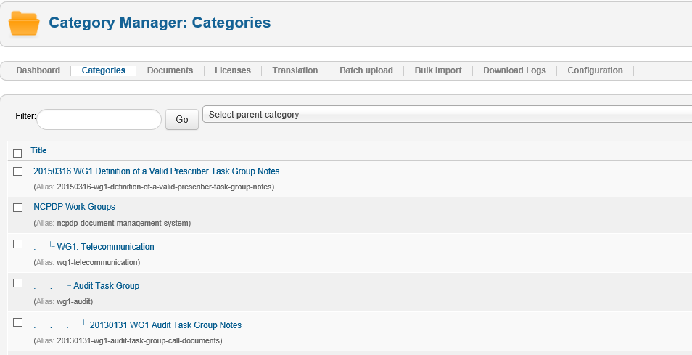

Here is what we want to do:
- Do not select a parent category.
- Enter “Audit Task Group” in the Filter and press Go.
- Have EDocman filter the list to show the “Audit Task Group” category row.

Here’s what happens now, the “Audit Task Group” category row is not shown:
