Project Brief - Pendulum Consultancy

- Project Stakeholders
Name | Role
Chong Yen Wong | RWP Owner, Project Manager
Anthony Xavier | Project Manager, Systems Administrator

- Current Project Opportunity

The “Rent with Pets” (RWP) project aims to provide pet friendly properties to tenants that own pets. It also provides a property management/investment features. RWP uses Joomla as its content management system. Joomla is restricted by necessary features required on RWP. There are a number of installed Joomla extensions that are currently installed. The current project opportunity revolves around the OS Property extension that provides the support and management for real estate properties. Currently this extension is requiring necessary modifications for it to be more useable by RWP users.

The OS Property Extension can be found on (http://joomdonation.com/)

- Competitive Websites

There are a number of real estate property websites already available. None however provide for the provision of pet friendly properties. The current search engines that RWP is trying to mimic with the inclusion of pets are:

http://www.realestate.com.au –
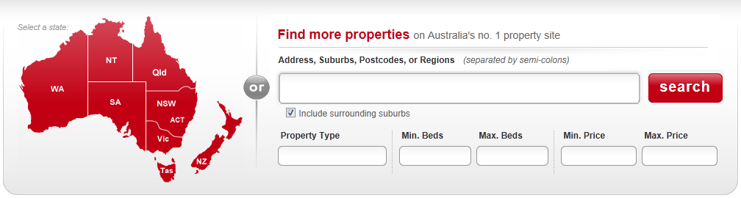

http://www.domain.com.au –
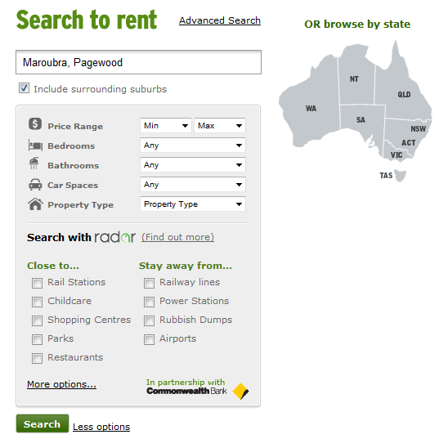

- Competitive Websites, Continued

None of these above websites provide provision for pets. RWP is different because it does. That is its selling point to tenants and property agencies, managers and investors.

- Modification(s) Required:

There are a number of crucial modifications required for this extension to be useable by RWP. The reason why RWP persists with OS Property is that provides a very unique and extensible framework. It has a lot of features but with the required changes it will become a lot easier for RWP users to use effectively for looking for new properties.

4.1 User Inputs

Currently most inputs are via select boxes:
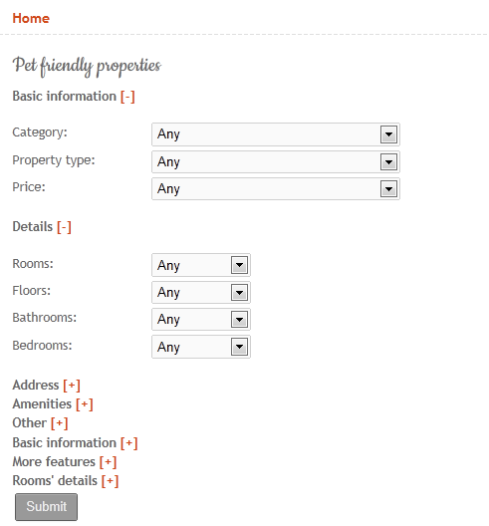

This needs to change drastically. Under Basic Information, we should have the similar fields like www.realestate.com.au and www.domain.com.au for example, the RWP user should be able to do a search on:

Fieldname: Search Criteria <input type=”text” size=”?” name=”searchCriteria”>

Field | Type | Example
Suburb | String | Ashfield
Postcode | INT[4] | 2015
Region | String | Sydney Western Suburbs

Fieldname: #ofPets <input type=”select” size=”2” name=”NumPets”>

Field | Type | Example
numPets | Enum | 1, 2, 3, or 4 pets

Fieldname: petType <input type=”select” size=”20” name=”petType”>

Field | Type | Example
petType | Multi-String | Small Dog, Large Dog, Cat, Rabbit etc

Fieldname: minPrice/maxPrice <input type=”text” size=”6” name=”minPrice”>
<input type=”text” size=”6” name=”maxPrice”>

Field | Type | Example
minPrice | Currency | 1,500.00
maxPrice | Currency | 1,750.00

2. Advanced button

Taking for example www.realestate.com.au and www.domain.com.au they have buttons to show more details in their users search requests. We would like to have a “More options” button as well. This will show the following information under this block:

Details More features
Address Rooms details
Amenities Other

3. Requires property alert feature

If a RWP user wishes to save this search criteria we would like them to sign up or save this information under a button called “Add to property alert”.

System Information:

Project website: http://rentwithpets.com.au
Admin website: http://rentwithpets.com.au/joomla/administrator/index.php

FTP Information:

Hostname: sgp3.siteground.asia
Directories: /www/joomla/components/com_osproperty
/www/joomla/modules/mod_ospropertysearch
/www/joomla/modules/mod_ospropertyajaxsearch?
/www/joomla/modules/mod_ospropertyrandom?

