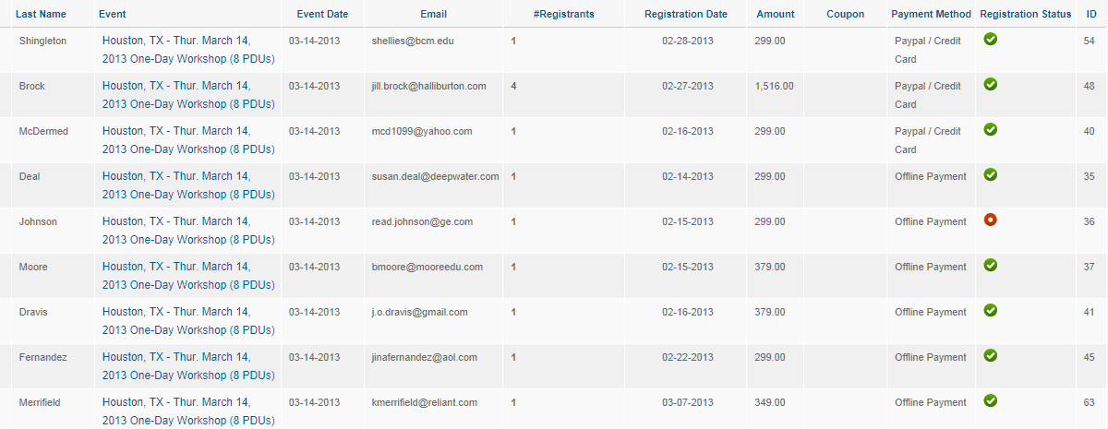
Payments that are $379 are ones without a coupon. All others that are <$379 should have a coupon code listed.

