The goal:
It is required that you can select several events on the weekly/month calendar.
http://dev2.zwingli-zentrum-toggenburg.ch/de/wochenkalender

The current state:
There is already a feature "Cart Modul" in the EventBooking which can show the different events in a cart module. There is also a "Calendar" feature, which presents all events in a day / week / month view.
Now the problem is that as soon as you click on the event in the calendar view, the view can’t be displayed correctly. So there is a problem with the interaction of these two modules.

Good example:
http://dev2.zwingli-zentrum-toggenburg.ch/de/event-a
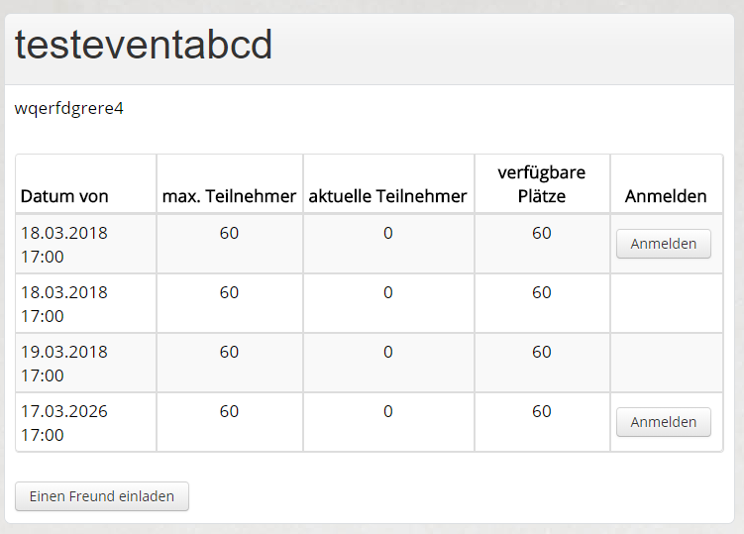
As soon as you click on "Login", the window will appear, which you should also see in the calendar view.
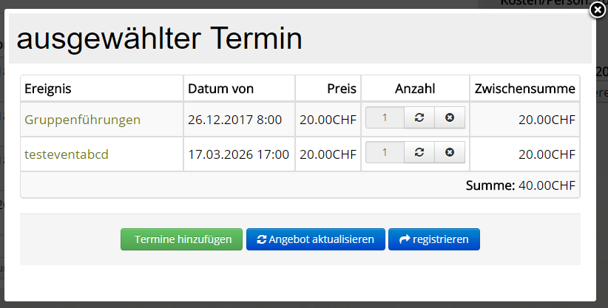

Bad example:
http://dev2.zwingli-zentrum-toggenburg.ch/de/wochenkalender
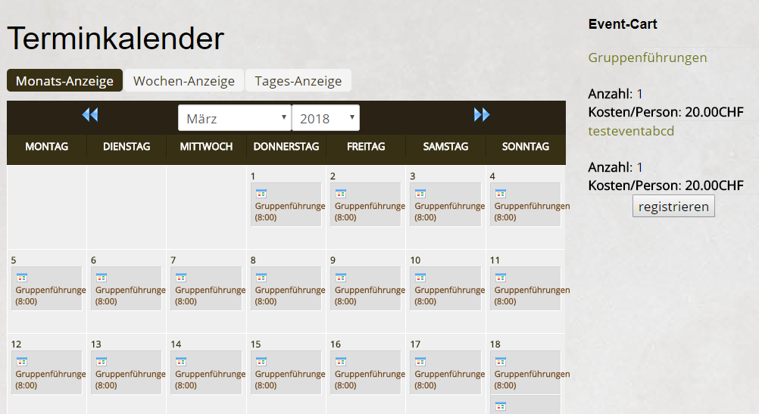
As soon as you click on an event in the calendar view, the following display appears:
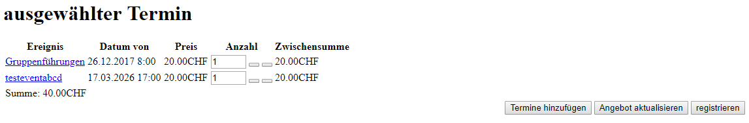
You must create a link between these two modules so that the selected events are displayed correctly in the cart module.
Important Folder:
dev2/htdocs/components/com_eventbooking/

