We feel that this has some unclarity.

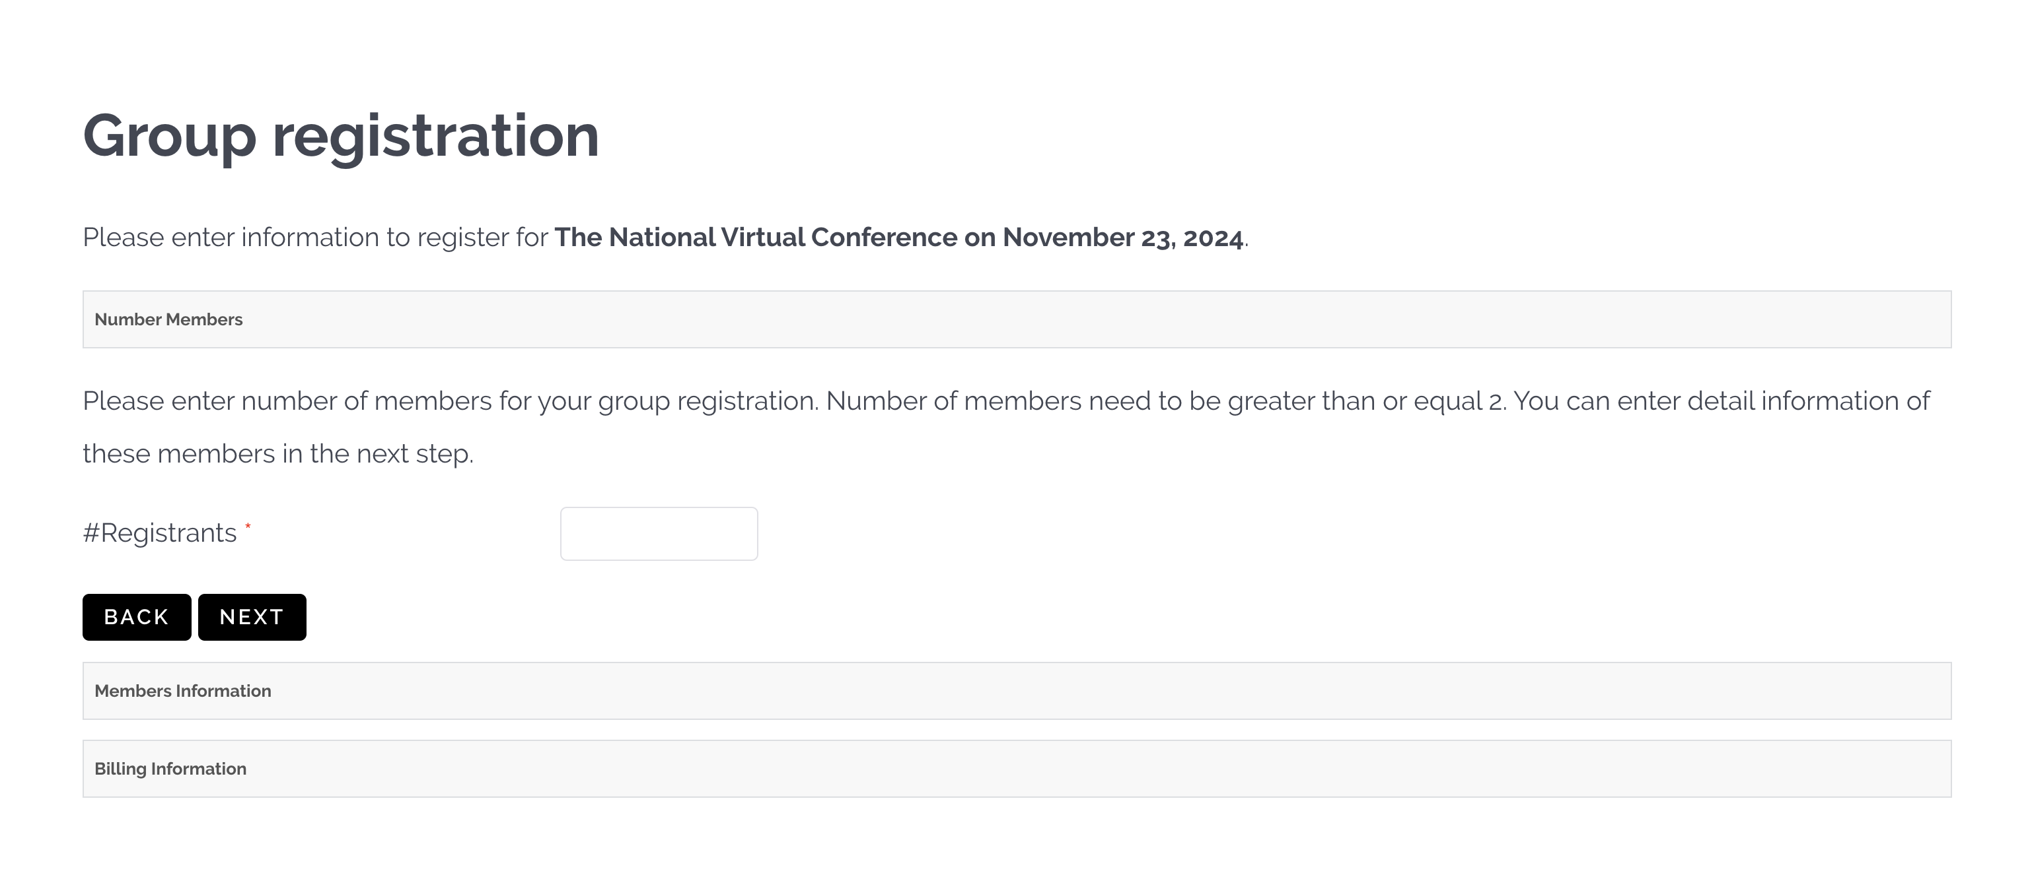

This looks like this is where you need to enter number of registers

This box is not dark enough to see and # changed to “Number of”

These subtitles are confusing

These boxex is not dark enough to see

Enlarge Process button, change color and center to make more prominent.

Add a calculating field that allows for additional Donations