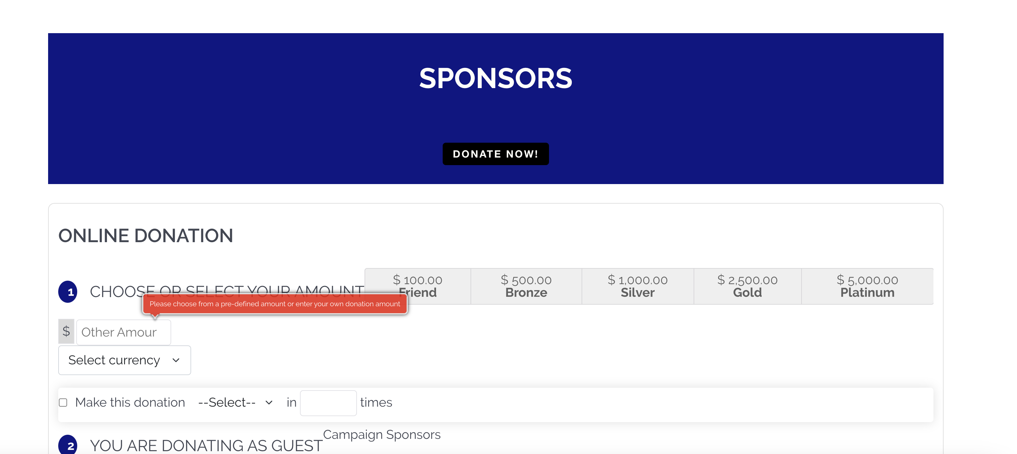

Have multiple currency options but US dollar be default

Change blue field to white (which I know how to do)

Chang text to black