Specification Sheet

Our platform is an e-commerce website specializing in the sale of clothing and image consulting, built on Joomla 4 (upgradable to Joomla 5). The management of the store is handled by the Eshop extension version 3.8.0. We do not have any additional components for users.

The site is multilingual, currently in French and English, but it is expected to include other languages in the future.

Objective
The store must display to customers a selection of products that are specifically recommended based on their physical characteristics such as body shape, color profile, and other aspects (detailed further on).

To collect this data, customers must register and fill out a form to collect their criteria.

To manage the display of these recommendations, the developer will need to integrate a 'My Custom Shop' button within the 'Eshop Product Filter' module, which will allow users to activate or deactivate this feature as they wish.

Note: The developer will need to document the modifications to adapt to updates.

Joomla and Eshop ‘user’ relationship
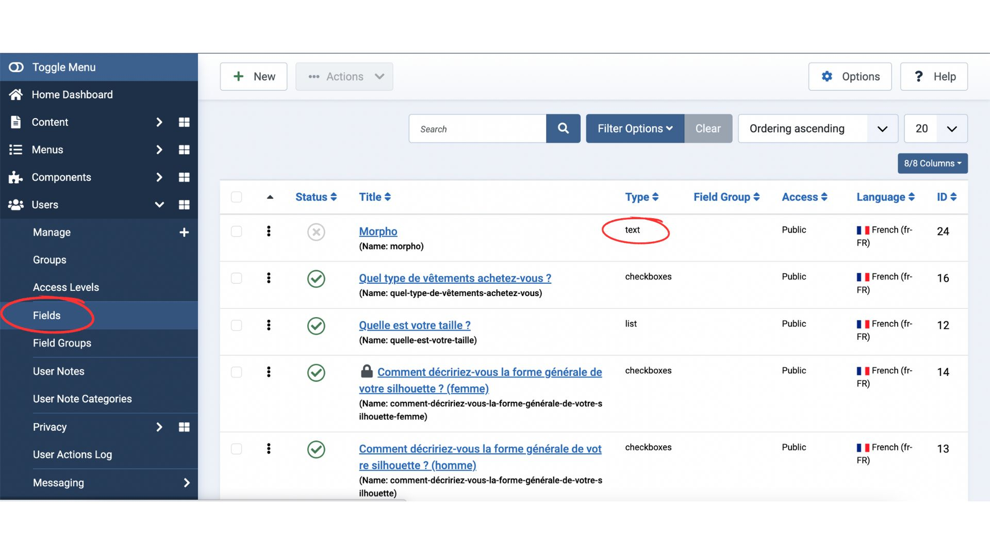
To retrieve this information, we want to use the custom fields provided by Joomla at registration. (We provide more detail regarding the question later on.)

In Eshop, during the creation of products, we will assign values to the products.
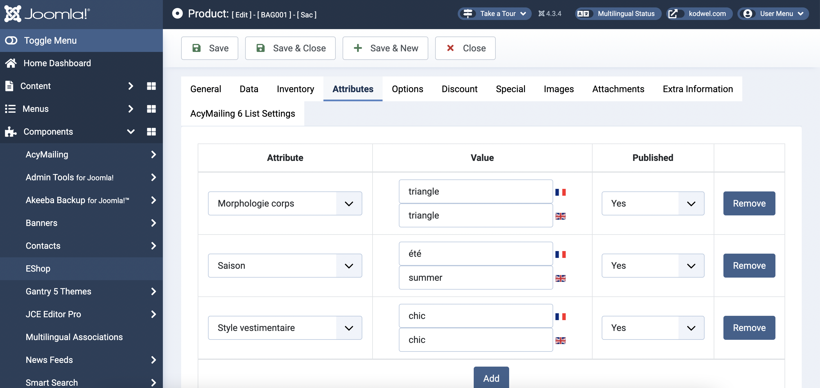

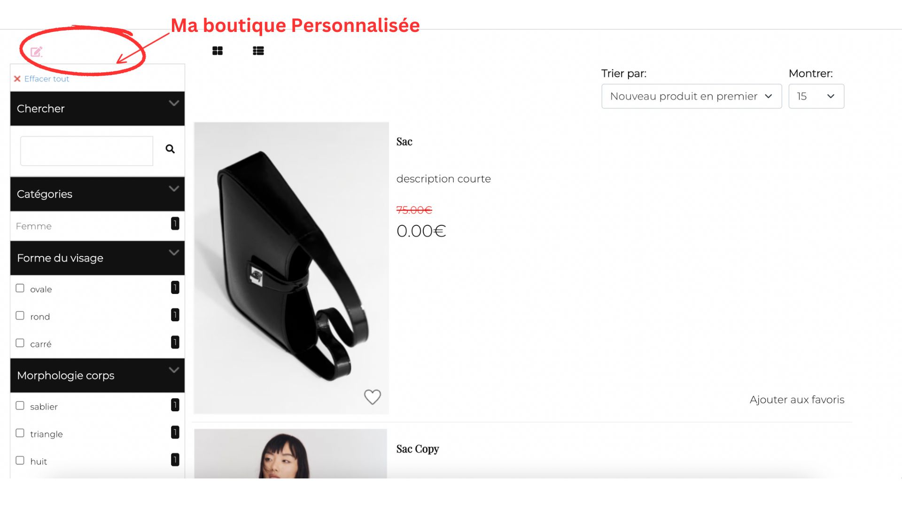
The goal is that only the products with values that match the customer's profile will be displayed. A button needs to be added to the Eshop Product Filter module: My Custom Shop, above all available search elements. It can be activated and deactivated. It is active by default.

THE QUESTIONNAIRE

Since we are using 'fields' to collect data, the questionnaire currently appears when a user wants to register. It can be found in the section named 'fields'.

The registration page is then composed of 4 parts:
- Account Creation
- Fields
- User Profile
- Terms and Conditions of Use
See here: https://kodwel.com/fr/enregistrement-user.html

Objectives:
- We want to rename 'fields' to: Activate My Custom Shop
- We want the questionnaire to be separated from the rest of the registration process.
- We want to modify the component so that the proposed answers are displayed with photos. We are thinking of using the field: type of field > text, and modifying the code.
- We want the questions/answers that appear to be different depending on the response to the first question. *In reality, these are the same questions but the possible answers are different depending on the chosen gender (see diagram).

Note: There must be a French version and an English version.

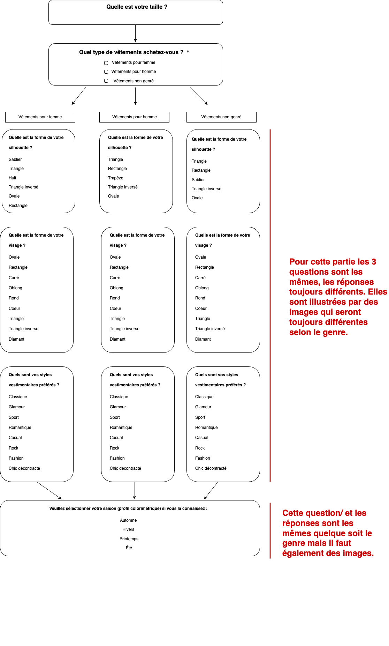
The questions:

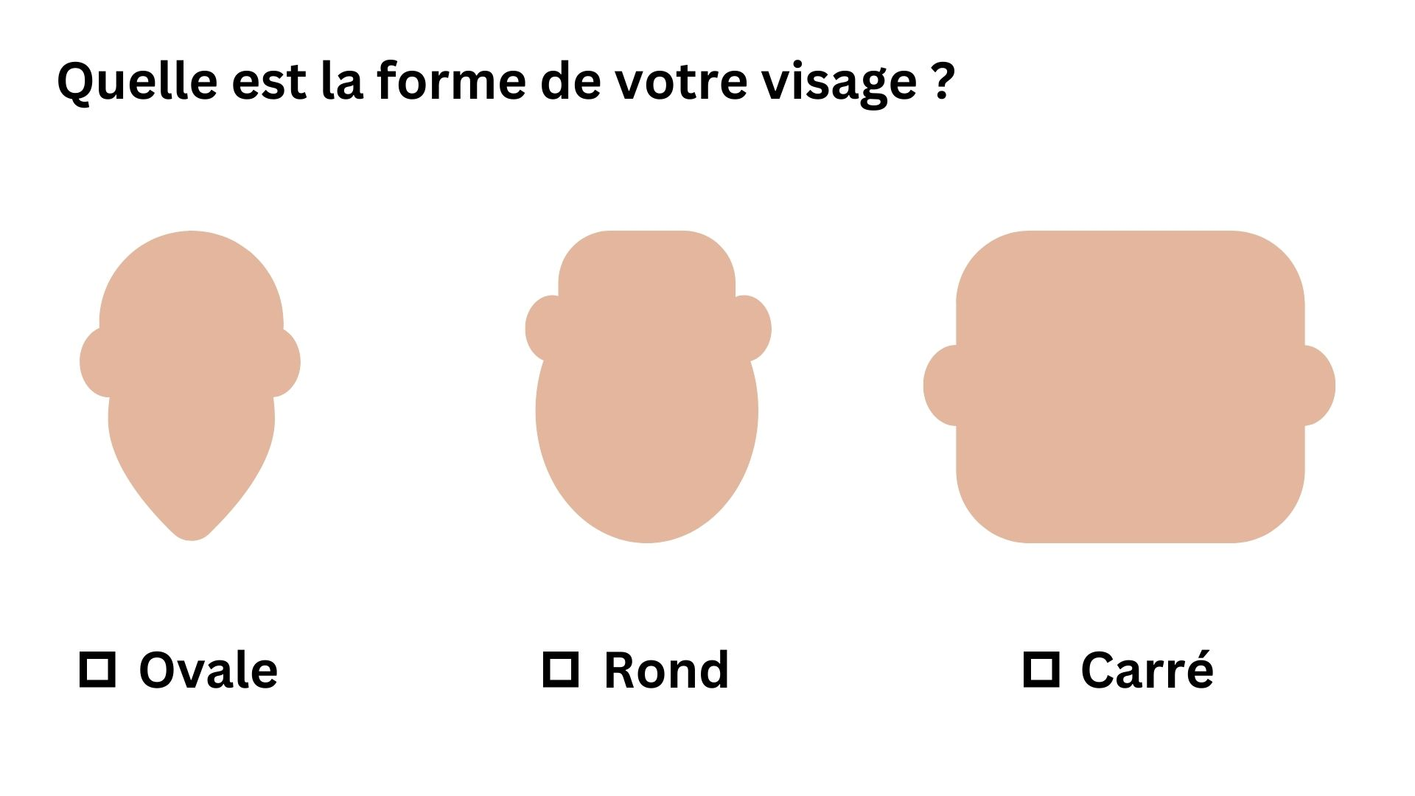
Example of the visuals with pictures :

E-SHOP SIDE

The module needs to be modified to display only the products that match the custom fields of the user's profile.
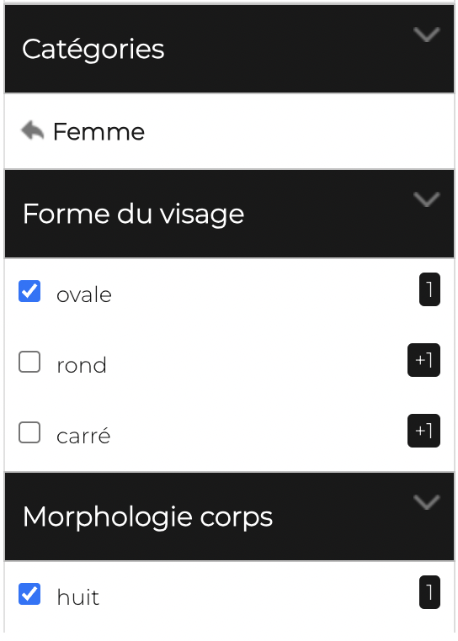
When a user is registered, the 'Activate My Custom Shop' button is enabled by default. If possible, the fields corresponding to their profile are checked.

If the user decides to click on another field, then the 'Activate My Custom Shop' button gets deactivated, and the user is free to conduct their own search. However, it should reactivate normally if the user returns to the shop later.

