**Compost Giveaway Application Form**

First Name: Last Name:

Phone #: Email Address:

Residential Address*: * *

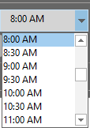Appointment Date*: Appointment Time*:

Please select your choice of compost *

Six free bags of compost approximately 200kgs

Six free bags of compost plus extra bags at $2.00 per bag bags

Bulk Compost purchase at $35.00 per ton less 200kgs of free compost

Submit