Only members (active). Should only get individual discount
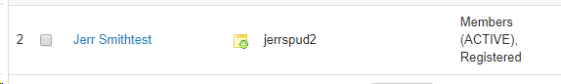

Discount settings
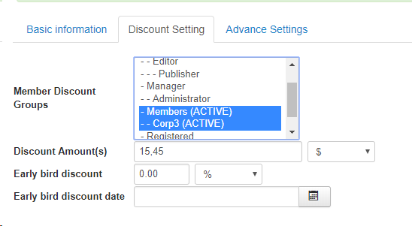

Check out should only be $15 discount, but when I do a group of three… it discounts the entire amount.

A different account has the same problem even when the event has no Corp discount set 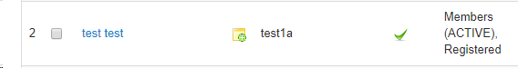

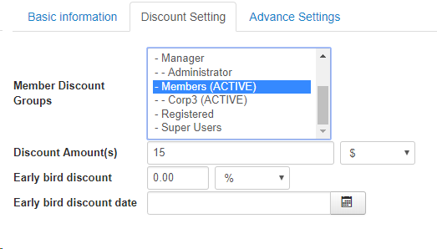
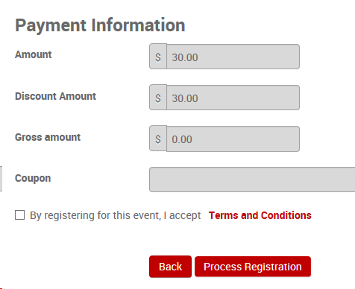
I just want it to give only a $15 discount …
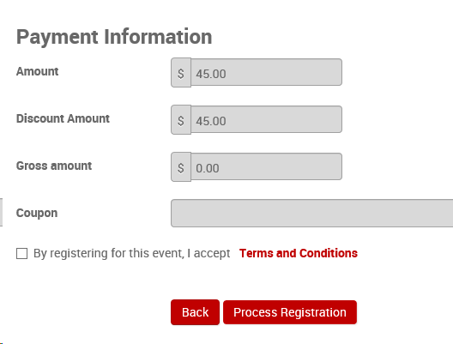
Discount is more than $15.

