**Subscription Manager: Edit Subscription**

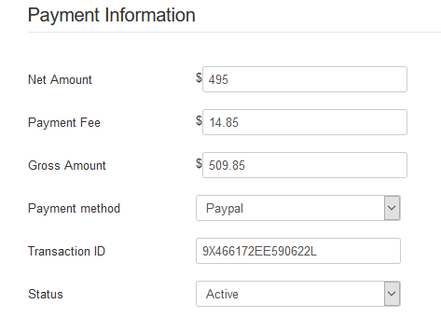

Using standard accounting terms, the Gross Amount should be $495 and the Net Amount should be $509.85

<https://writingexplained.org/gross-vs-net-difference>

This is for a subscription …

**Plan Manager: Plans**



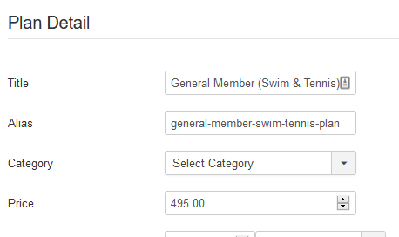

Changing translations may be a good solution provided the underlying math is correct.

I believe

“Net Amount” – could just be “Price” (same as in Plan Detail)

And “Gross Amount” – could be “Payment” (using terms from the Payment Plugins)

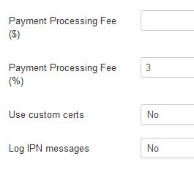

This might become confusing in the database since you use the names “Amount” and “Gross Amount” there..

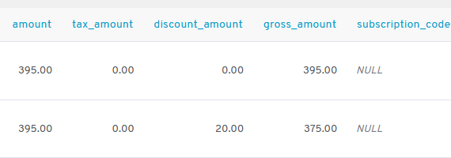

In these columns, “Amount” would be “Price” ; and “Gross Amount” would be “Payment”