changed the translations for OSM_GROSS_AMOUNT and OSM_NET_AMOUNT (added (Payment) and (Price))

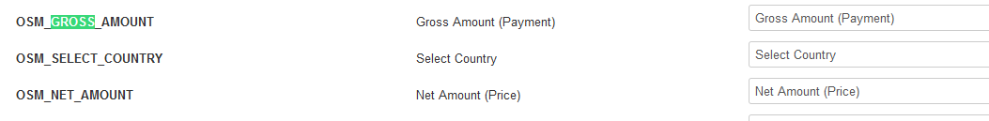

Translations show on frond end for Manage Memberships..

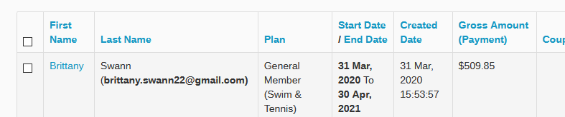

And on back-end Subscription Manager / Payment Information ..

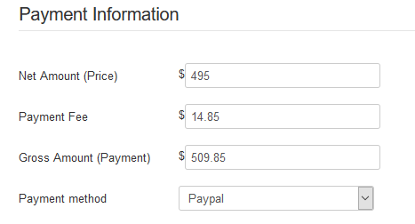

But not in the back-end for Subscription Manager : Subscriptions column names

