Here is how I set the plan at the back-end.

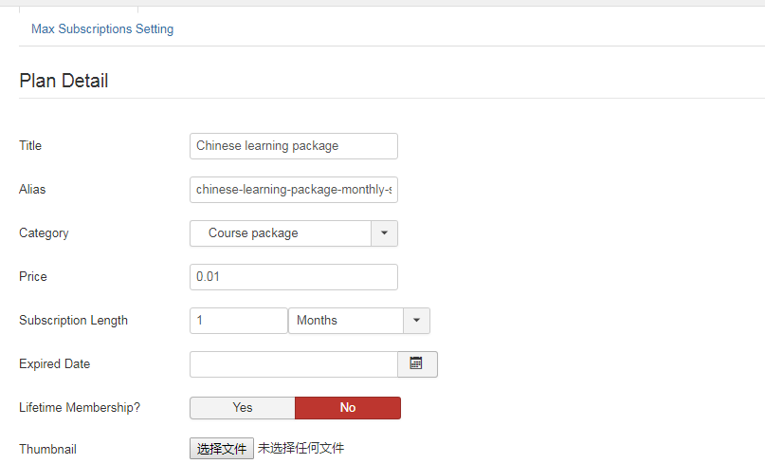

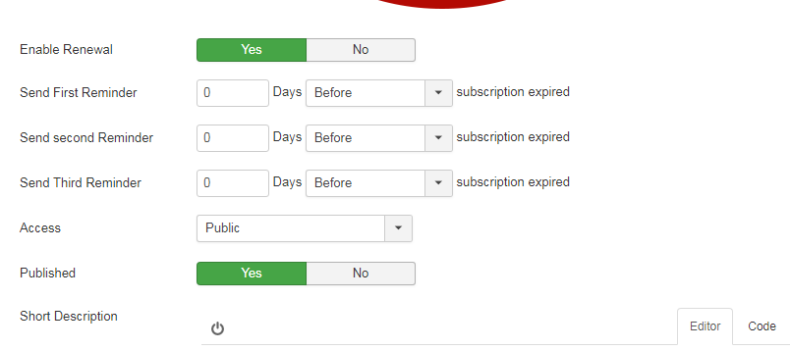

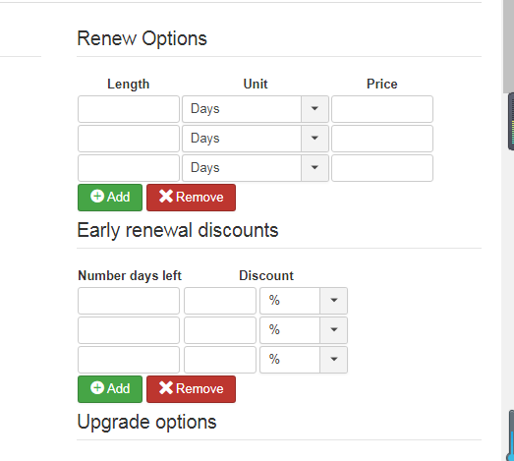

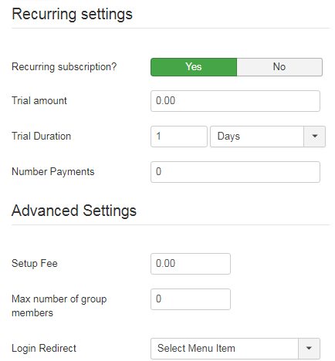

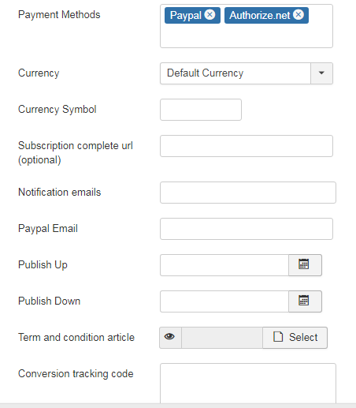

At the Front end, I tested with this account: alan/19950307

<https://www.worldedu.us/stores/course-package-subscription/member-center>

I can see the tab “My Subscription”, but I didn’t see “Cancel” button.

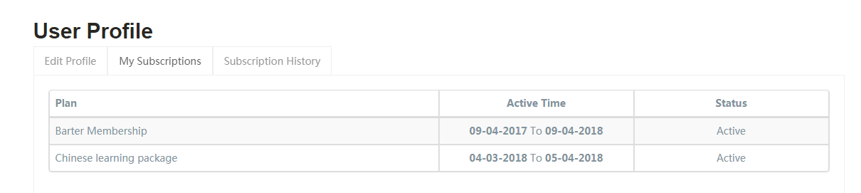

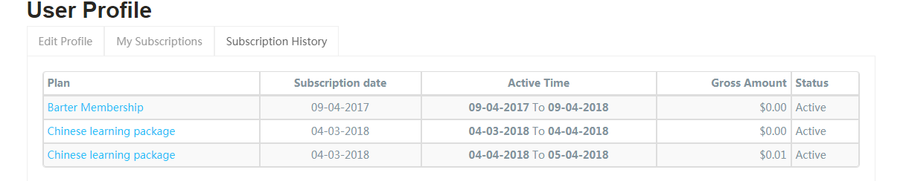

Did I set something wrong? Can you help me? Thanks.