See the calendar at <http://foodsystemsnetwork.org/index.php/training-calendar>

Monthly calendar view:

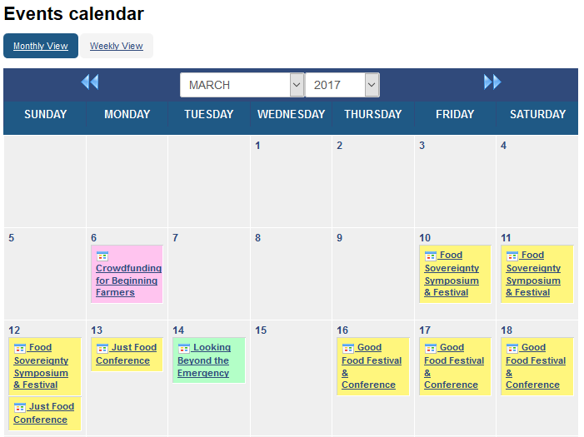

Is there a way to remove the tiny calendar icon? It doesn’t serve any purpose and just clutters the view.

Long description has some issues:

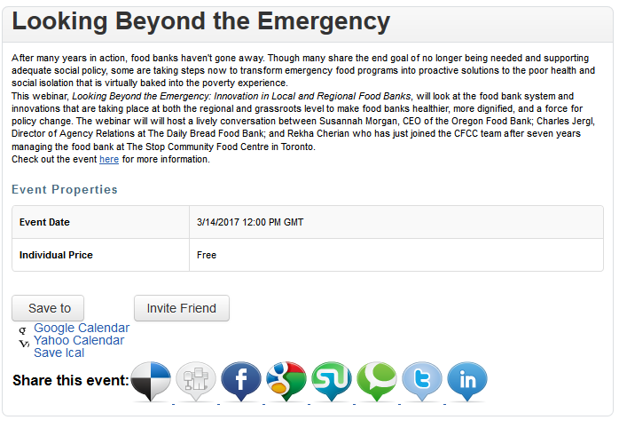

Should be shown in Eastern Time; Joomla server is set to “New York.” I’ve tried UTC and get the same result here. Why can’t I choose a timezone as I enter an event, too?

I’m not sure what the dots below the icons are. Is something not being displayed?

Icons for the calendar options are misaligned.

Weekly Events view:

Why does the Weekly view open to this week (the first one with an event), rather than the current week? It does this even if I choose to Hide Past Events.

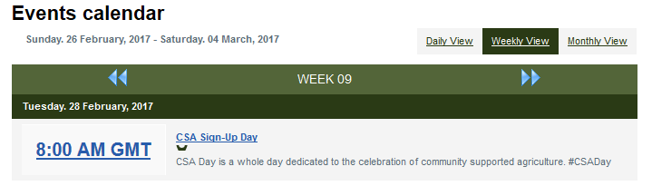

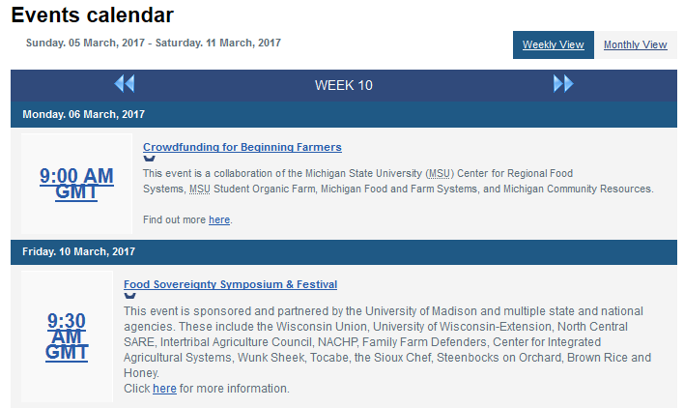

Too-large font size so rows overlap. Should be shown in Eastern Time; server is set to “New York.”

Where do I change the setting for this date format?