no-warning-message-in-shopping-cart-when-option-quantity-is-0

- “Stock Checkout” set to No

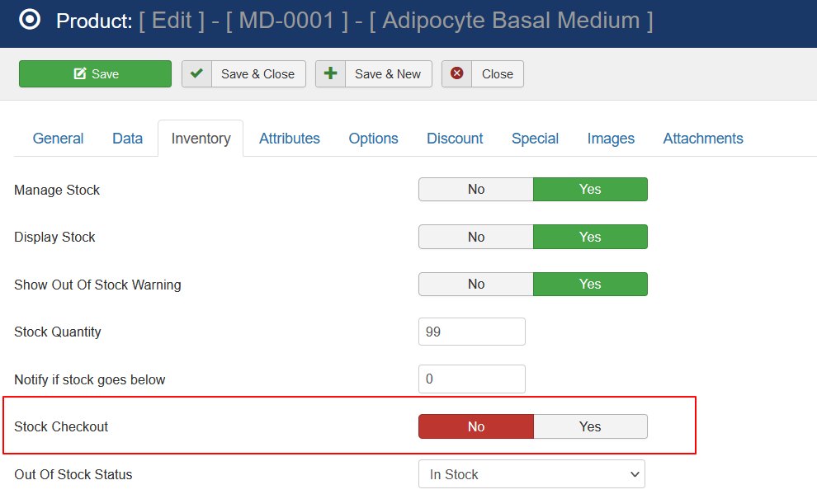

- Option quantity set to 0

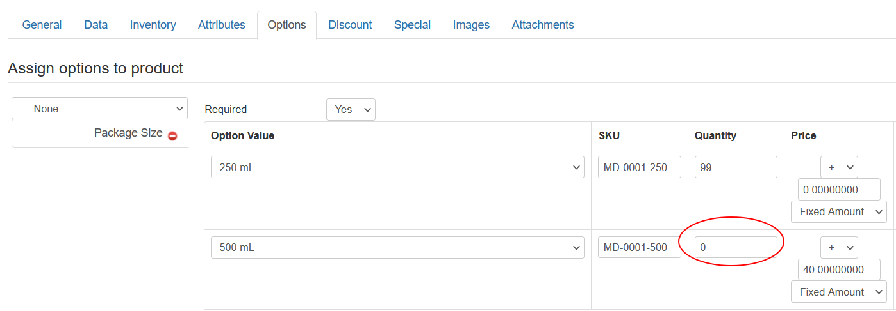

- No warning message in shopping cart and checkout process will go through

