This document shows a registration date-time error. The first screen shows the event in the backend.
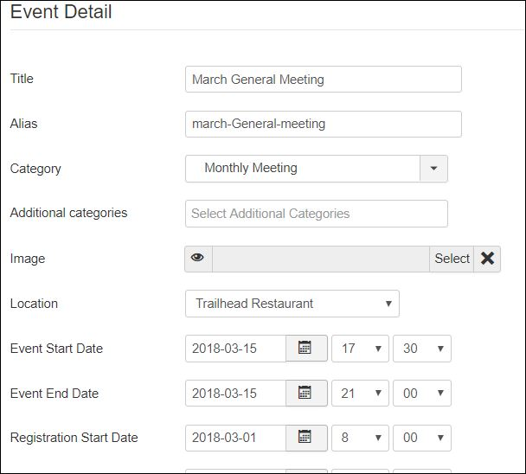
The next screen shows how the registration start date is listed correctly in the front end detail display.
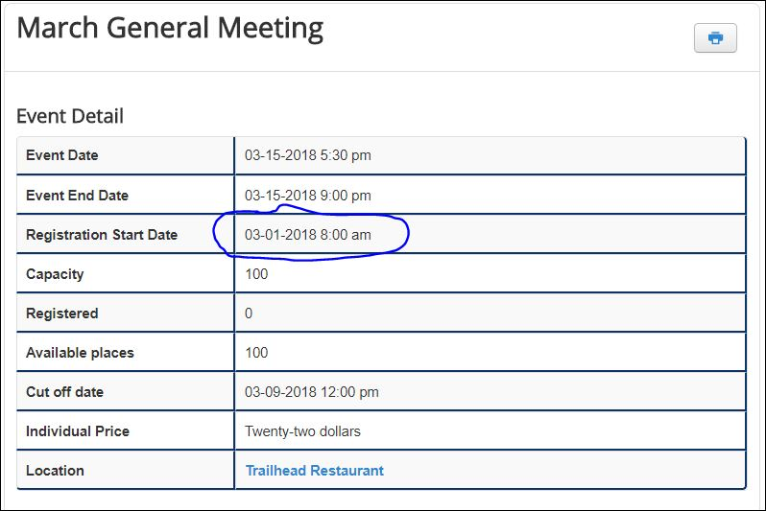
The next screen shows how the registration start date is listed incorrectly in the table format display.
