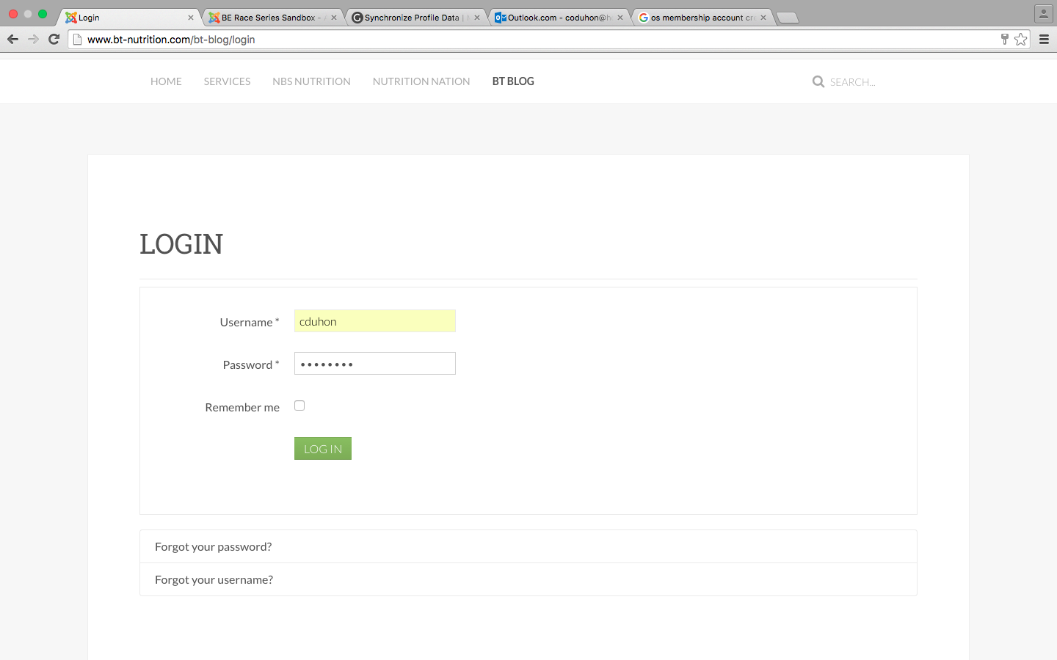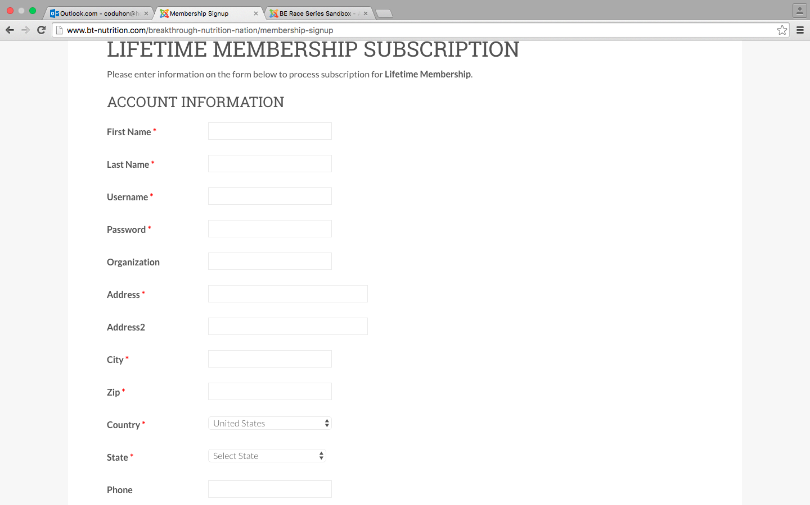

I would like for the username and password, which is mandatory on the membership sign up page to integrate with the Athlete Login module in the upper right hand corner. That way when they sign up for a membership, an account is created for them and they can sign into the site and get access to restricted material.