„HOW to“

multilanguage usage

how tin OS Property templates
(based on Real Home template)

1. Add a multilanguage switcher
2. System Language Filter
3. Creating category
4. Adding content
5. Associate the articels
6. Creating the menu in multilanguages
7. Add a module to menu
8. New homeside default
9. Creating a multilanguage megamenu

1. Add a multilanguage switcher

Click on Extensions choose Module Manager and create a new modul

Give the new modul a name and choose „Position“ (eg. Topbar-1). Save and close dialog

Click on Extensions choose Plugin Manager and search for filter and activate the System Language Filter.
Click save and close

First creating category in your langugage
Click on content / category / new

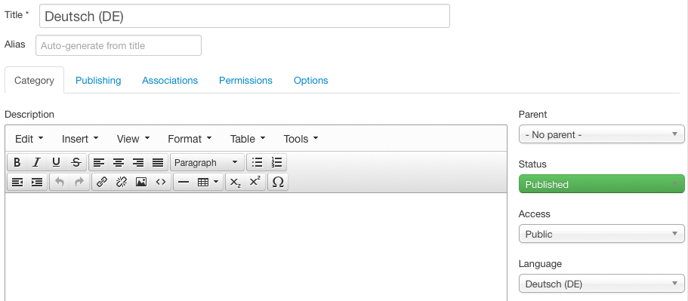

save and close
make the same with english language
4. Adding content in category

Click on content / articels / new

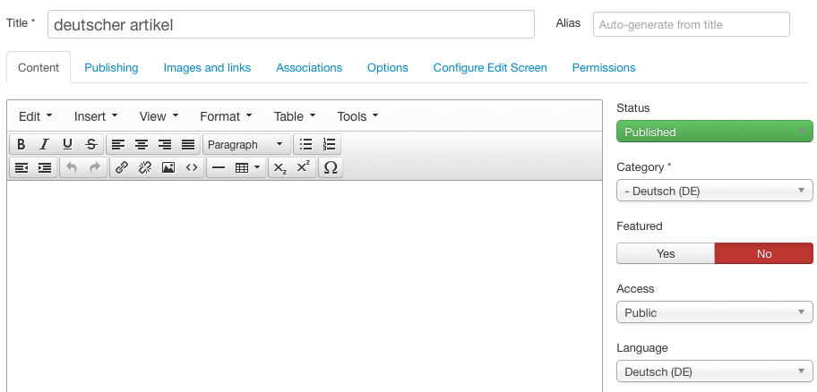

choose the language which the artikel will have on right side.

Make the same with an englisch articel and save and close it.

5. associate the articels

After it you have to associate the articels. Open one new created articel and choose assosciations. See picture. If u can´t choose one of the field u didn´t activate the language in article.

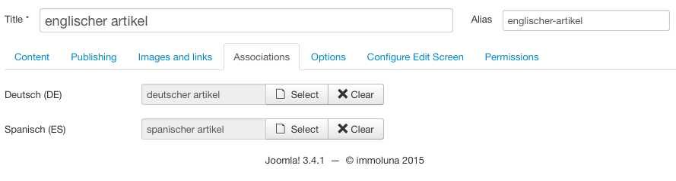

save and close

6. creating the menu in multilanguages

click on menus / menu manager and select Add new menus

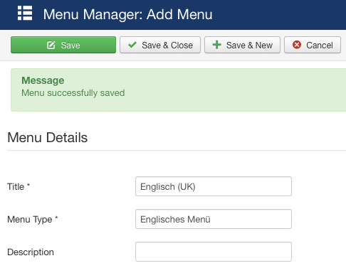

create one for each language

7. add a module to menu

now we have to add a module for this menu. At the present it look like this:

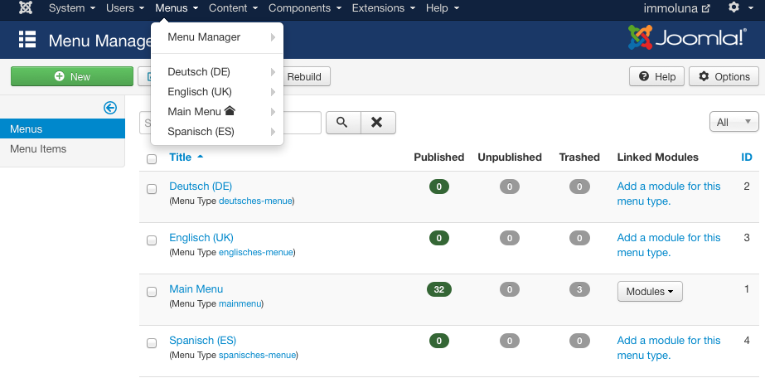

Here u see that the Main Menu which is standard have already a modul. This one we will hide later

Click on menus, choose menu in your language and add new menu item

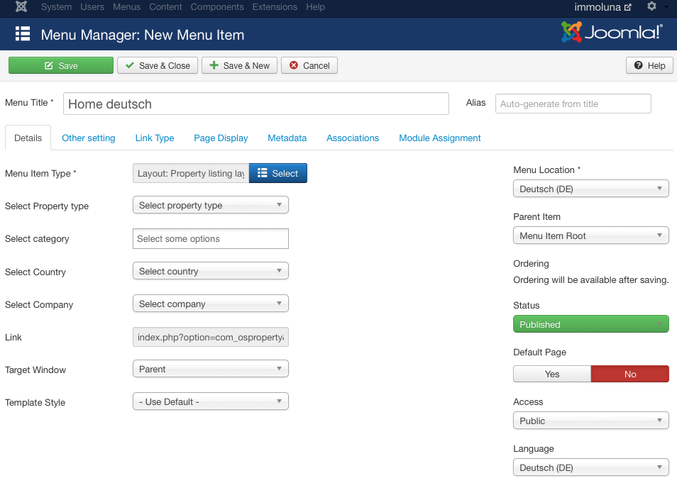

reopen one of your created „home“ item and associate it

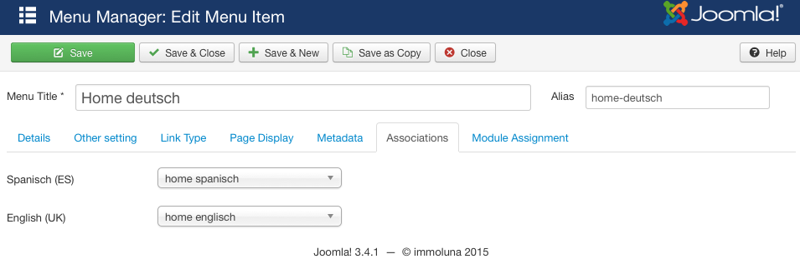

8. new homeside default

now the new home in your language need to be the default of the page

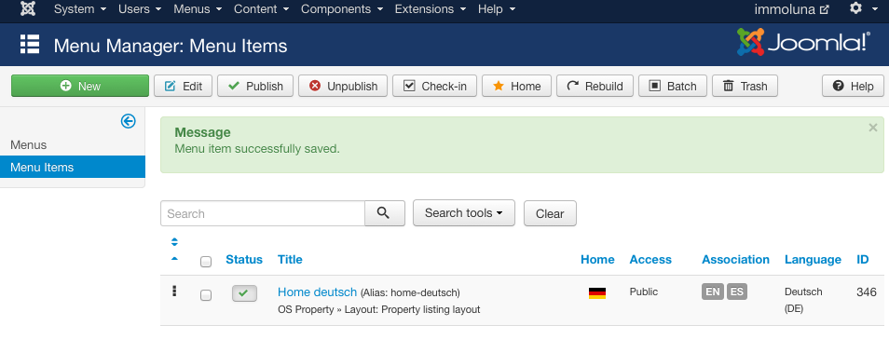

after clicking on the star under home, the correct flag of this country is shown

9. multilanguage megamenu

Creating a multilanguage megamenu which is under control of OSP Real Home

Go to extensions / Template Manager

mark OSP Real Homes – Default and click edit

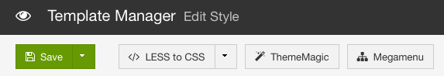

now we have to copy the default

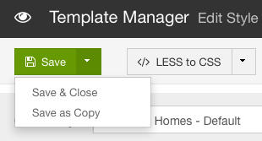

Rename the default as u like and change language which you have installed. In my case ist OPS Real Homes – Deutsch and save it first

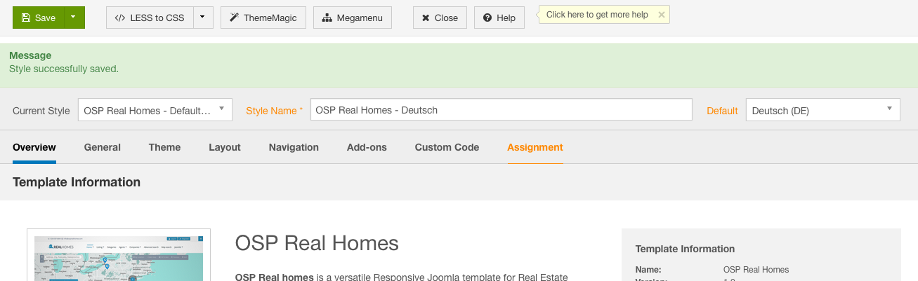

now go to Navigation, choose in Menu your language and take a look that switcher is on by Enable MegaMenu

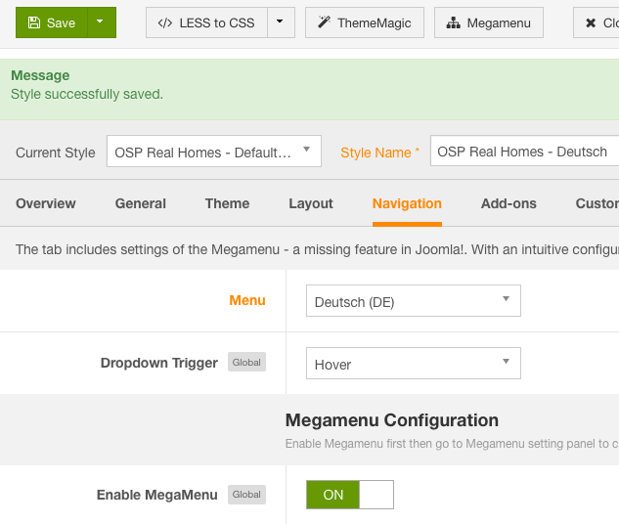

at the end do the same with your other languages. Click first to Current Style: OSP Real Homes – Default and then save as copy and rename it.

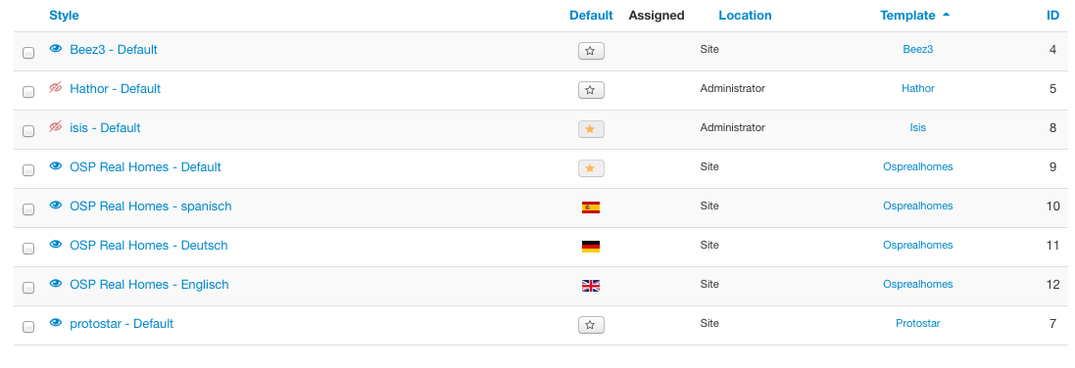

The OS Real Home default with star ist the default. All other will shown with a country flag

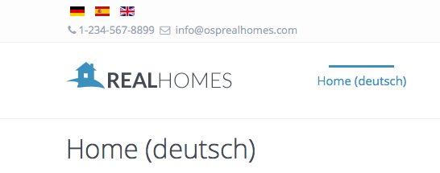

Now you create the first menu in your language, time to fill the menu ;-)

Welcome tot he international world of OS Real Home

Thanks to Dang Thuc Dam for this wunderfull template

-- I hope that my „HOW TO“ solve your problem --

Written by
bernhard.eismann@t-online.de
28. Mai 2015, München

