Details from the front end export

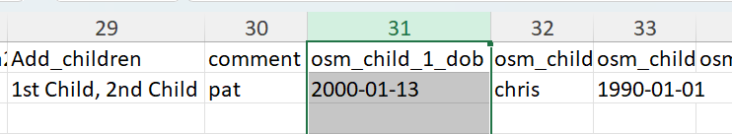

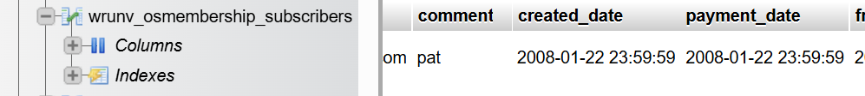

The only thing I can find the same is the ‘comment’

