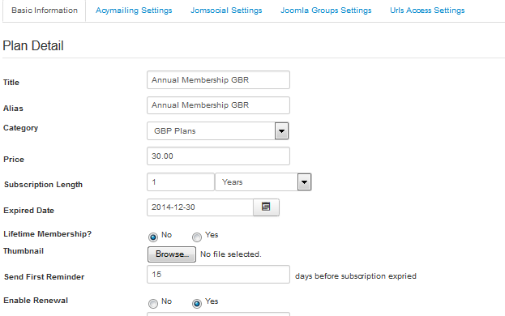
Plan set with Fixed expiry 30-Dec-2014

Renew for one year
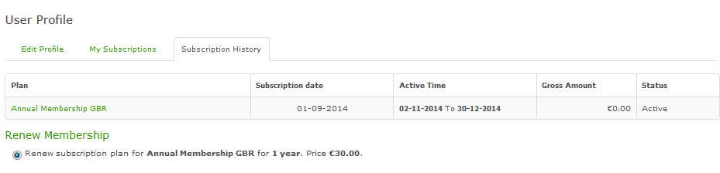
Result = 1 year renewal
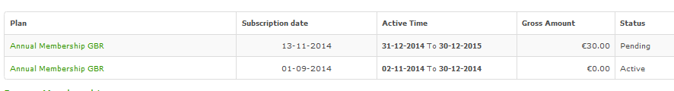

Plan set with Fixed expiry 31-Dec-2014
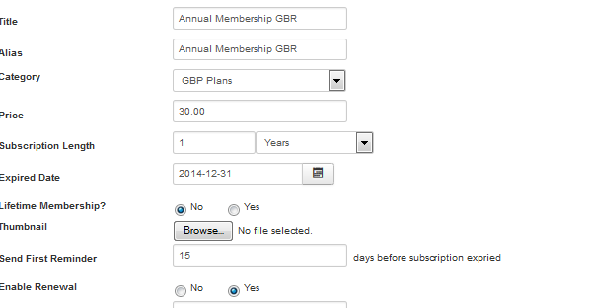
Renew for one year
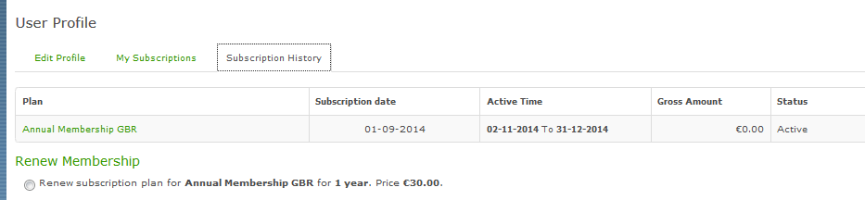
Now renewed for 2 years!

