Managing Listing times

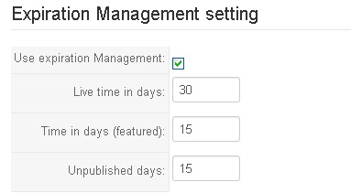

In above picture, you will see 3 fields.
- Live time in days: One property will be availble at frontend of your Property system in this time range. After that, it’s status will be changed to unapproval.
- Time in days (featured): One property will be “featured” at the frontend of your Property system in this time range. After that, it’s status will be changed to Normal. It can be approval or unapproval in this time.
Notice: Featured properties are always shown at the top of any listing page.
3. Unpublished days: When the property is changed to unapproval, agent has this time range
to request approval it. After this time range, the property will be removed out of Property system.

