Documentation for DMS PDF Stamping

Prerequisites
To use PDF stamping you need a couple of things in place.
For your Joomla installation ensure you have the following PHP settings:
- Safe mode = Off
- shell_exec needs to be allowed. Make sure you do not have shell_exec in the disable_functions list

The pdftk library
The PDF stamping is done using pdftk.
pdftk allows you to manipulate PDF easily and freely. It does not require Acrobat, and it runs on Windows, Linux, Mac OS X, FreeBSD and Solaris.

Installing pdftk
pdftk lives here: http://www.accesspdf.com/pdftk/
If you are using shared hosting you need to ask your hosting provider to make this library available for you.
If you have a dedicated server you can find installation instructions on the web site above.
For Ubuntu linux all you need to do to installation pdftk is this command:
sudo apt-get install pdftk
Note that there is an error with the build of pdftk on Ubuntu Linux 9.10 Karmic Koala:
https://bugs.launchpad.net/ubuntu/+source/pdftk/+bug/450544/
To get around the problem follow these instructions:
http://www.trancefussion.com/blog/?p=101

Verify pdftk is working correctly
Go to the <joomla_install_directory>/components/com_dms/libs/pdftk directory.

Execute the following command:
pdftk stamp.pdf fillform formdata.xfdf output test.pdf flatten

If the test.pdf file is created succesfully you are good to go. Remember to open the pdf file and verify that everything looks right.

If you have the Ubuntu error mentioned above you will get the following error:
Helvetica-Bold not found as resource. (The *.afm files must exist as resources in the package com.lowagie.text.pdf.fonts)

Unhandled Java Exception:

ExceptionConverter: com.lowagie.text.DocumentException: Helvetica-Bold not found as resource. (The *.afm files must exist as resources in the package com.lowagie.text.pdf.fonts)

at com.lowagie.text.pdf.Type1Font.<init>(itext-2.1.5.jar.so)

at com.lowagie.text.pdf.BaseFont.createFont(itext-2.1.5.jar.so)

at com.lowagie.text.pdf.BaseFont.createFont(itext-2.1.5.jar.so)

at com.lowagie.text.pdf.BaseFont.createFont(itext-2.1.5.jar.so)

at com.lowagie.text.pdf.DocumentFont.doType1TT(itext-2.1.5.jar.so)

at com.lowagie.text.pdf.DocumentFont.<init>(itext-2.1.5.jar.so)

at com.lowagie.text.pdf.AcroFields.decodeGenericDictionary(itext-2.1.5.jar.so)

at com.lowagie.text.pdf.AcroFields.getAppearance(itext-2.1.5.jar.so)

at com.lowagie.text.pdf.AcroFields.setField(itext-2.1.5.jar.so)

at com.lowagie.text.pdf.AcroFields.setField(itext-2.1.5.jar.so)

at com.lowagie.text.pdf.AcroFields.setFields(itext-2.1.5.jar.so)

Where is PDFTK installed?
If your hosting provider installed PDFTK for you they can provide you with the path to the library.
If you have a dedicated linux server you can find the correct path by issuing this command:
$ which pdftk
/usr/bin/pdftk

So on Ubuntu the correct path is /usr/bin.

Enabling PDF Stamping
On the main page for configuring DMS you will find the settings for PDF stamping.
Enable PDF stamping and enter the correct path to the pdftk library.
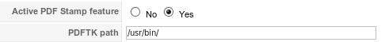

PDF stamping will now work for paid documents.
The email address of the buyer will automatically be put on every page of the document.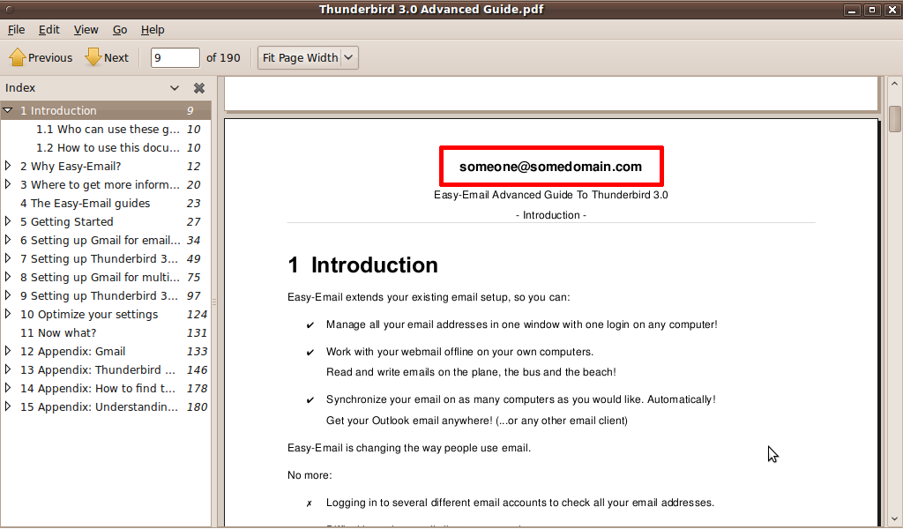

Tip. If you do not want the email address to appear on the front page you can put an image on this page and it will hide the email address.
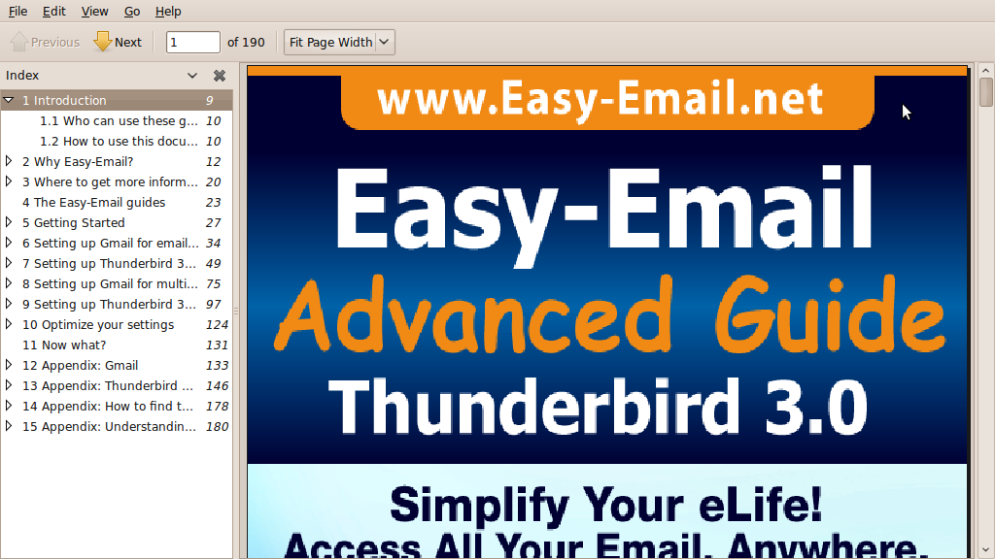

Changing the location and formatting of the email address
By default the email address is placed in the top of the document.
The location and formatting of the email address is determined by the stamp.pdf document, which is located in the <joomla_install_directory>/components/com_dms/libs/pdftk directory.

Before making any changes please back up this file.

To create a new stamp.pdf follow these steps:
- Install OpenOffice. You can get it here: http://www.openoffice.org. It is free.
- In OpenOffice Writer create a new document – stamp.doc.
- Create a text box form control. Place where you want the email address to be stamped into your document.
You can use the settings shown here or modify fonts etc as you please.
The supplied stamp.pdf uses Read Only, Cortoba 12 Bold as font, no border and Alignment Center.
Important. The field has to be named email (in the properties for the text box).
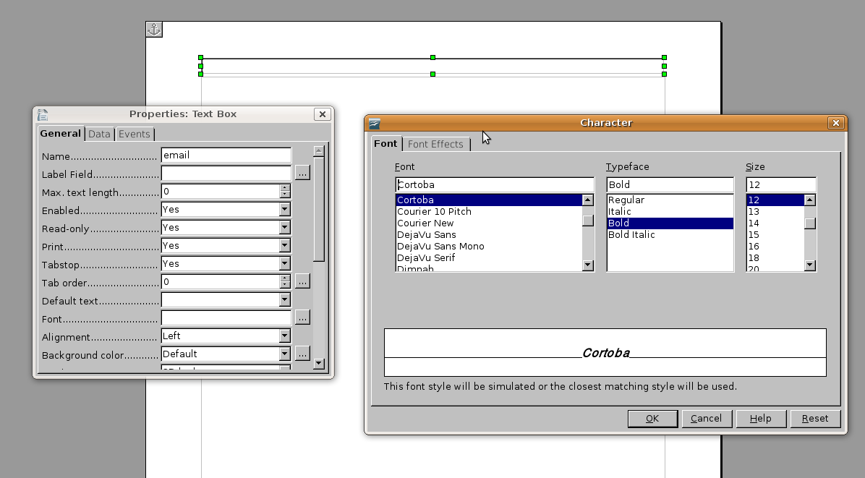
- Go to File → Export as PDF.
Choose Create PDF form.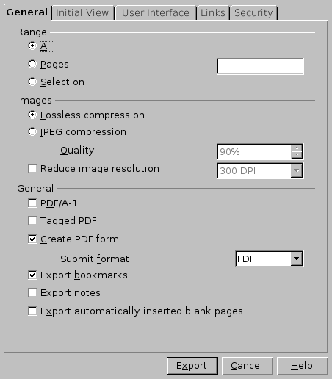
The file will now be called stamp.pdf.
- Replace the old stamp.pdf with your new stamp.pdf file in the <joomla_install_directory>/components/com_dms/libs/pdftk directory on the server.
- Test!

