Hi, Tuan

You replied to my earlier post as follows:

2. If I click on a registrant to change some data and then Save, AND if there is a Custom Field, a second copy of the custom field is written to jos_eb_field_values. This causes some strange things in SQL queries. I believe this problem existed in earlier versions also.

=> I just checked again and didn't see the problem like you said. The data saves properly (it is updated to the registration record) and there are no duplicate records in the database table like you said.

Perhaps I didn’t explain the problem fully. I have a registrant (ID=36 for this test).

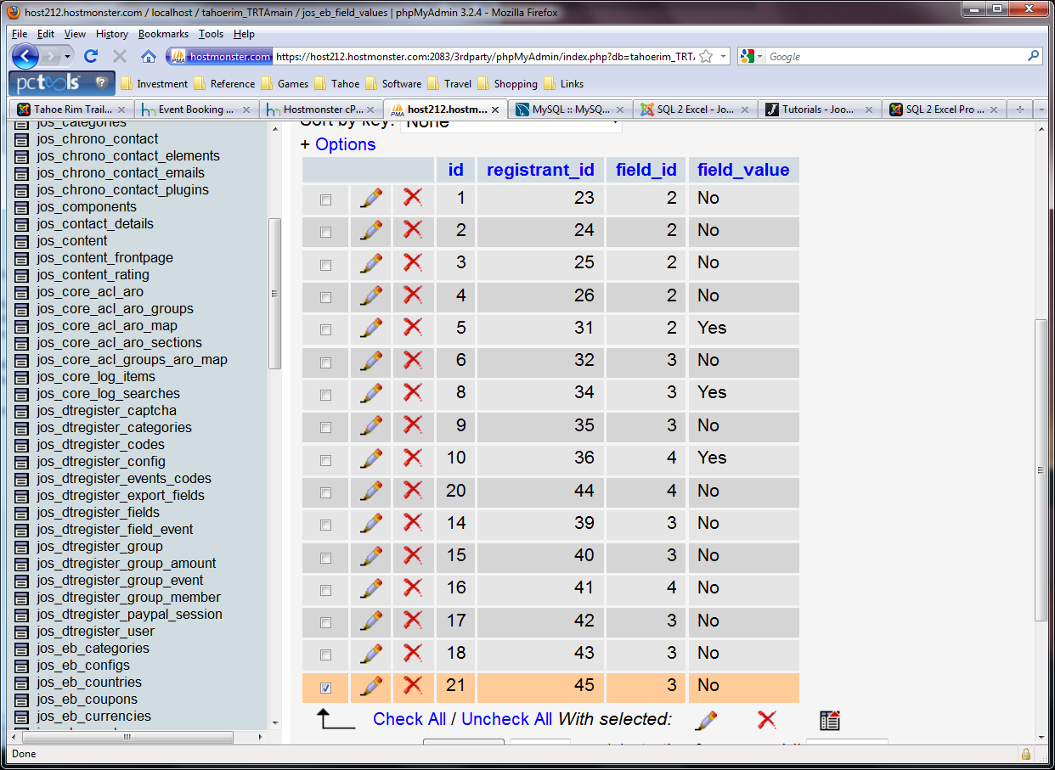

Note that record ID=10 contains an entry for field_id=4.

I then click on registrant 36 in Registrant Management. I do nothing and Save. Now jos_eb_fielde_values contains

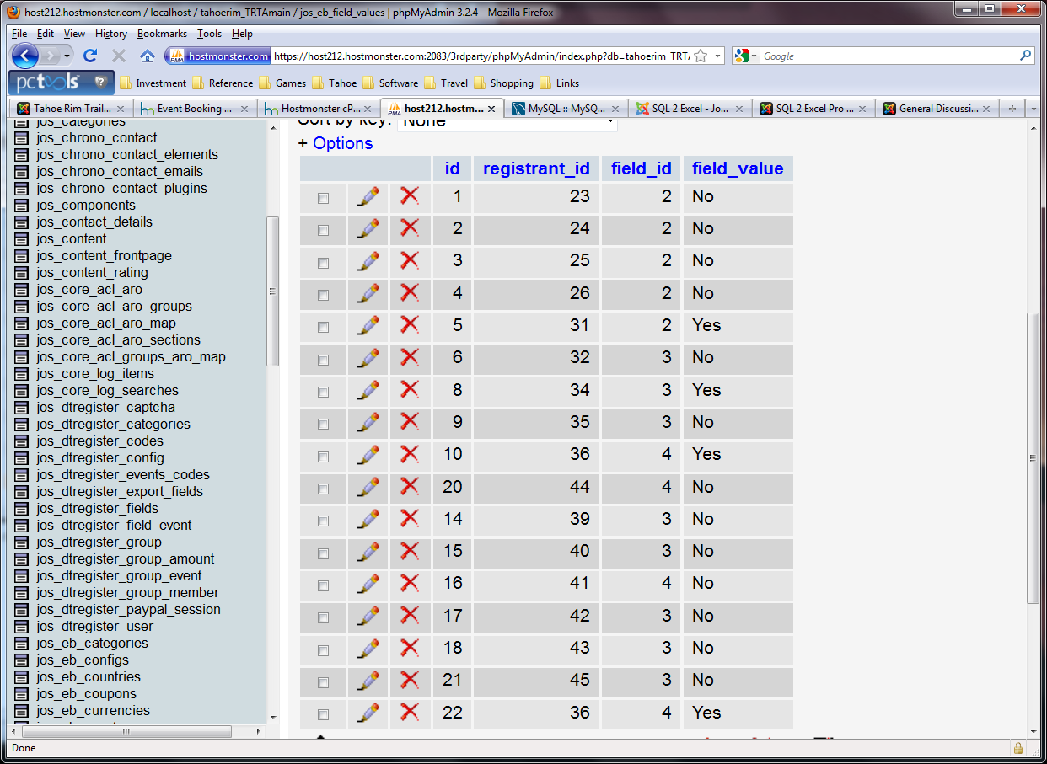

Anew record has been written, ID=22, duplicating the information in ID=10. This causes no problem in your Events Booking but when I try to run other SQL queries to produce, for instance, especially format rosters, it causes multiple report lines.